**Computer Engineering**

**COMP102**

**Lab Homework 4**

**Questions:**

1. A criticism of the break and continue statements is that each is unstructured. These statements can always be replaced by structured statements. Describe in general how you’d remove any break statement from a loop in a program and replace it with some structured equivalent. [Hint: The break statement leaves a loop from within the body of the loop. Another way to leave is by failing the loop-continuation test. Consider using in the loop-continuation test a second test that indicates “early exit because of a ‘break’ condition.”] Use the technique you developed here to remove the break statement from the program of Fig. 5.13.

#include <iostream>

using namespace std;

int main()

{

unsigned int count;

bool out = false;

for(count = 1; count <= 10 && !out; ++count)

{

if (count == 5)

out = true;

cout << count << " ";

}

cout << "\n Broke out of loop at count = "<< count << endl;

}

1. Write a program that uses for statements to print the following patterns separately, one below the other. Use for loops to generate the patterns. All asterisks (*) should be printed by a single statement of the form cout << '*'; (this causes the asterisks to print side by side).

[**Hint:** The last two patterns require that each line begin with an appropriate number of blanks. Extra credit: Combine your code from the four separate problems into a single program that prints all four patterns side by side by making clever use of nested for loops.]

(Drawing Patterns with Nested for Loops) Write a program that uses for statements to  
print the following patterns separately, one below the other. Use for loops to generate the patterns. All asterisks (*) should be printed by a single statement of the form cout << '*'; (this causes the asterisks to print side by side). 

**[Hint:**The last two patterns require that each line begin with an appropriate number of blanks. Extra credit: Combine your code from the four separate problems into a single program that prints all four patterns side by side by making clever use of nested for loops.]

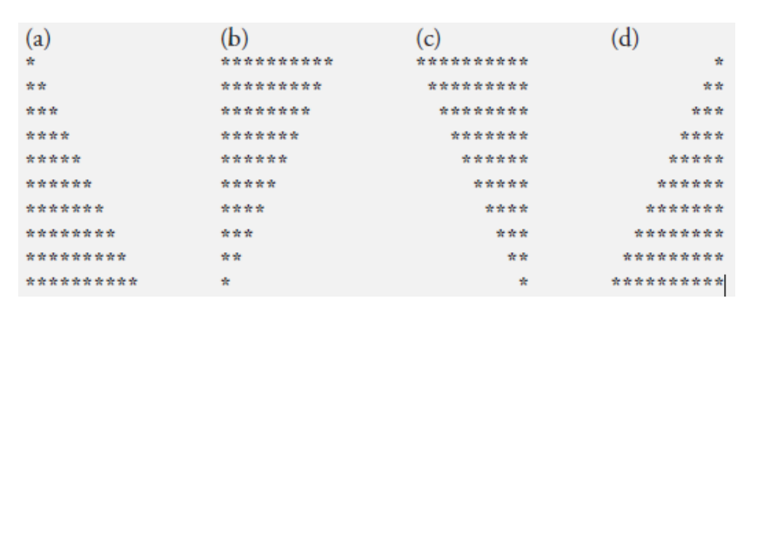

// 1st way : // <https://onlinegdb.com/mjLpikt-v>

#include <iostream>

using namespace std;

class pyramid{

public:

void pyramid_a();

void pyramid_b();

void pyramid_c();

void pyramid_d();

};

void pyramid::pyramid_a()

{

for (int i = 1; i <= 10; i++)

{

for (int j = 1; j <= 10; j++)

{

cout << (j <= i ? "*" : " ");

}

cout << endl;

}

}

void pyramid::pyramid_b(){

for (int i = 10; i >= 1; i--)

{

for (int j = 1; j <= 10; j++)

{

cout << (j <= i ? "*" : " ");

}

cout << endl;

}

}

void pyramid::pyramid_c()

{

for (int i = 10; i > 0; i--)

{

for (int j = 10; j > 0; j--)

{

cout << (j <= i ? "*" : " ");

}

cout << endl;

}

}

void pyramid::pyramid_d()

{

for (int i = 1; i <= 10; i++)

{

for (int j = 10; j >= 1; j--)

{

cout << (j <= i ? "*" : " ");

}

cout << endl;

}

}

int main(){

pyramid mypyramid;

mypyramid.pyramid_a();

cout<<"\n";

mypyramid.pyramid_b();

cout<<"\n";

mypyramid.pyramid_c();

cout<<"\n";

mypyramid.pyramid_d();

}

//2nd way <https://onlinegdb.com/RYW-m98m8>

#include <iostream>

using namespace std;

int main(){

char x;

cout<<"Enter a character, a, b, c or d"<<endl;

cin>>x;

if(x == 'a'){

for (int i =1; i<=10; i++){

for(int j=1; j<=10; j++){

cout << (j <= i ? "*" : " ");

}

cout<<endl;

}

}

else if(x == 'b'){

for (int i = 10; i >= 1; i--)

{

for (int j = 1; j <= 10; j++)

{

cout << (j <= i ? "*" : " ");

}

cout << endl;

}

}

else if(x == 'c'){

for (int i = 10; i > 0; i--)

{

for (int j = 10; j > 0; j--)

{

cout << (j <= i ? "*" : " ");

}

cout << endl;

}

}

else if(x=='d'){

for (int i = 1; i <= 10; i++)

{

for (int j = 10; j >= 1; j--)

{

cout << (j <= i ? "*" : " ");

}

cout << endl;

}

}

}